CSE 581

**Lab 8: Selects with Data Types**

1. **Select all data from the Orders table, ordered by OrderDate, newest date on top, for orders shipped between January 1997 and August 1997.**

SELECT *

FROM Orders o

WHERE (YEAR(o.ShippedDate) = 1997

AND MONTH(o.ShippedDate) BETWEEN 1 AND 8)

ORDER BY o.OrderDate DESC

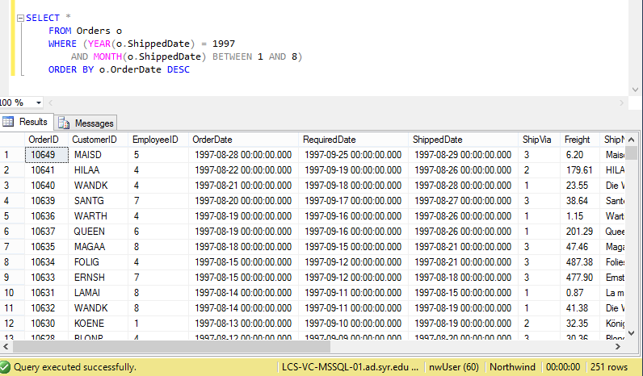

1. **Select all data from the Orders table, ordered by OrderDate, newest date on top, for orders placed between July 1996 and January 1997.**

SELECT *

FROM Orders o

WHERE (YEAR(o.ShippedDate) = 1996 AND MONTH(o.ShippedDate) > 6)

OR (YEAR(o.ShippedDate) = 1997 AND MONTH(o.ShippedDate) = 1)

ORDER BY o.OrderDate DESC

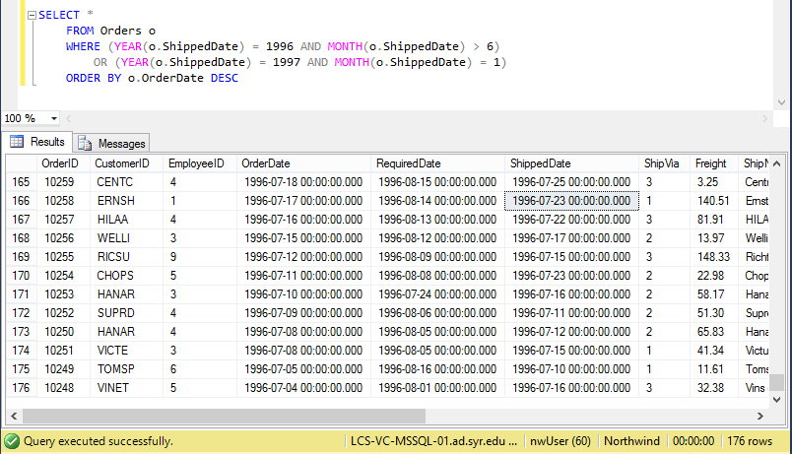

1. **Select all data from the Orders table, for orders placed in January 1998.**

SELECT *

FROM Orders o

WHERE YEAR(o.OrderDate) = 1998

AND MONTH(o.OrderDate) = 1

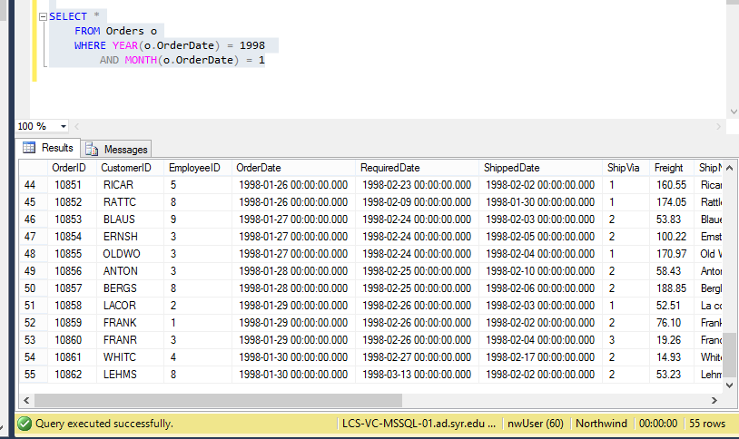

1. **Select count of Orders shipped in 1996, 1997 and 1998. (one query containing all values) -> 2 columns (count and year), 3 rows (1 row per year)**

SELECT YEAR(o.ShippedDate) AS Year, COUNT(*) AS NumberOfOrdersShipped

FROM Orders o

WHERE YEAR(o.ShippedDate) IN ('1996','1997','1998')

GROUP BY YEAR(o.ShippedDate)

ORDER BY YEAR(o.ShippedDate)

